Software engineering assessment 1 design document

Contents
User case diagram 2
Activity Diagram 2
Wireframes 2
Nathan: 3
Zach: 4
Fran: 6
Final Wireframes 7
Github link 8
Personas 8
Entity Relationship diagram (ERD) 9
Logical Data model (LDM) 10
Hardware and software requirements 10
Hardware Requirements 10
Software Requirements 10
Product specification 10
Product Name 10
Problem to solve 10
Target users 10
Product Goal 10
Scope 11
Out of Scope 11
Key Features 11
Tech Stack 11
Success Metrics 12
Constraints 12

User case diagram
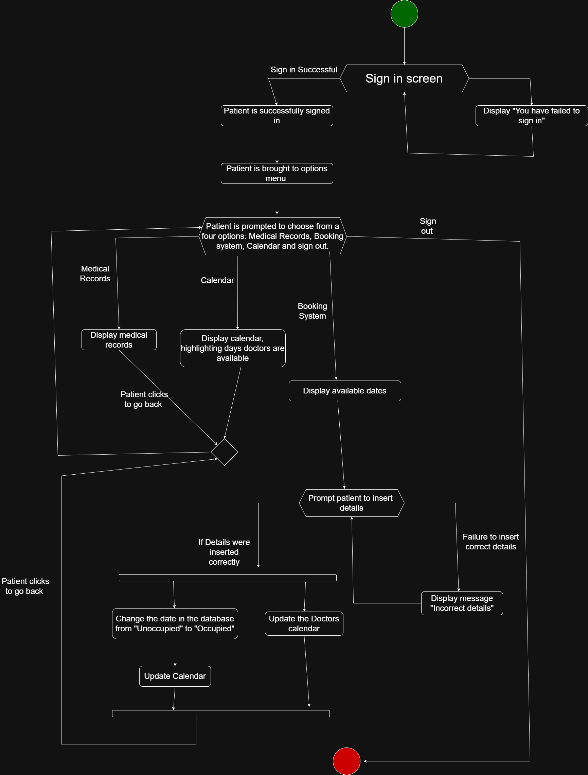

Activity Diagram
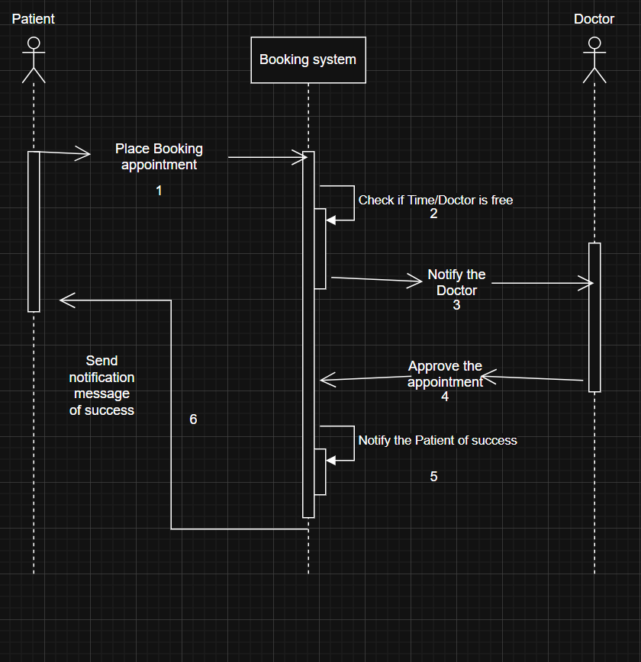

Wireframes
These are the mock-up wireframe designs:

Nathan:
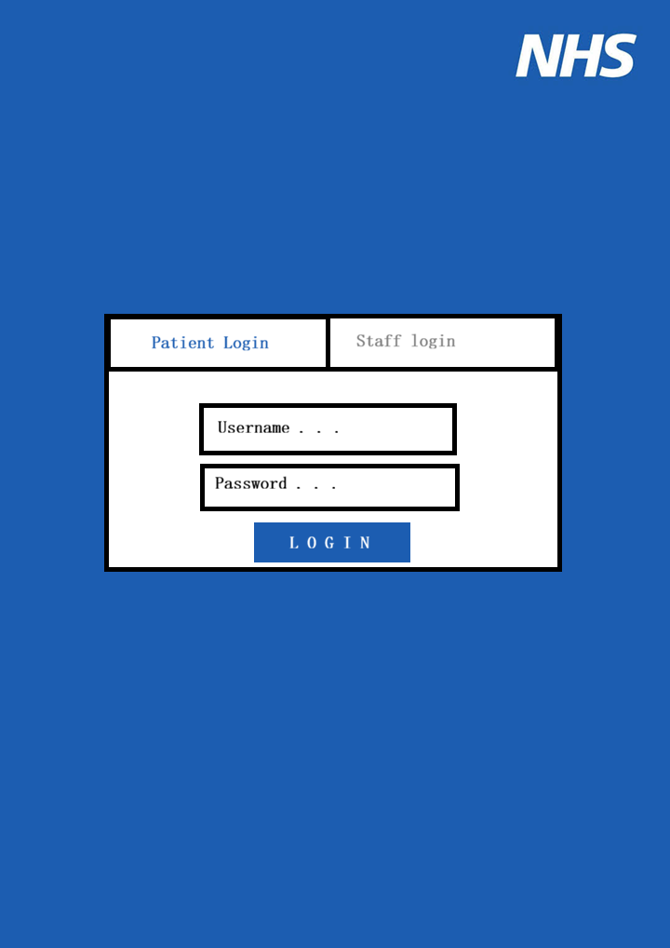
This is the first out of my two wireframes. Within this wireframe, I have created a simple login in screen. There are two buttons at the to switch between either staff or patient login. On top of this I have utilised a simplistic user interface, so that patients would not struggle with using the website.
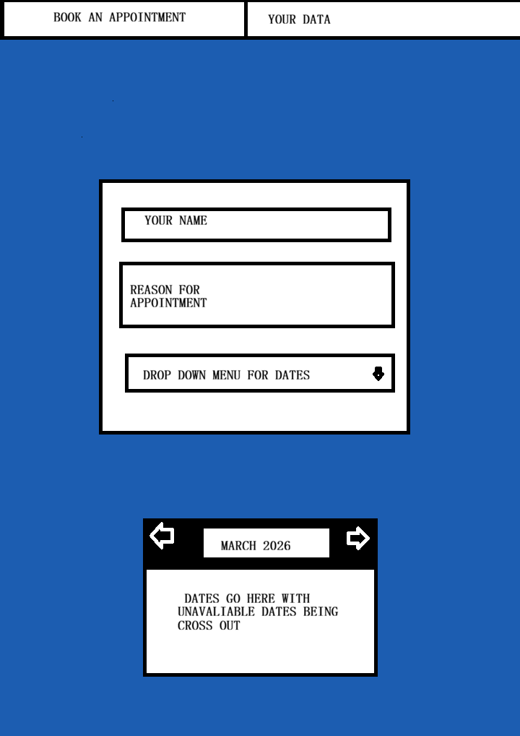
For my second wireframe, I have created the booking appointment screen. Within this page of the website, the patient will be able to enter their name, the reason for the appointment and a dropdown containing available dates. I have also included a calendar at the bottom, that would contain all the available months going up to next year. Finally, at the top I have included a header that would allow the patient to switch between “booking an appointment” or seeing their current medical data.

Zach:
This form is the Patient record form. This form is divided up so that you can see what your illnesses and conditions are on the left, the top right lets you see your appointment history and the bottom right has your info as well as which doctors you have seen.
I tried to lay out this information right to left having the most important information (the record of health) being the largest as I feel it is the most important. All UI elements can be scrolled through,
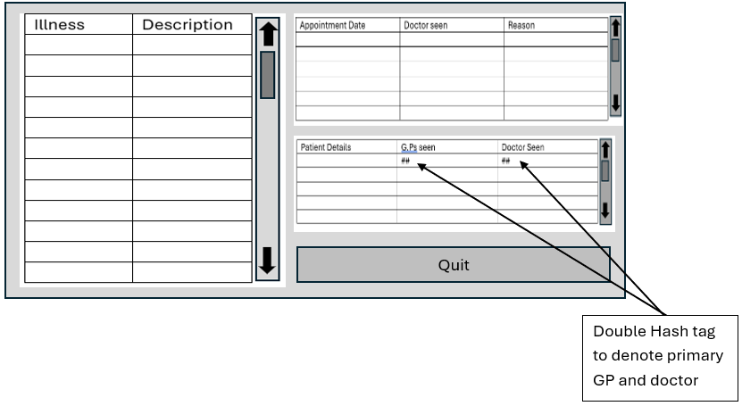
This next form is the appoitment booking and doctor availability form, while they are separate features my rational for combing them was they are incredibly interconnected and as such I decided to combined the two features into one form. To the left you can type you reason for and appoitment select your doctor in the middle is a calender that lets you select date and above the calender is two buttons to cylce between months and a drop down to select time.
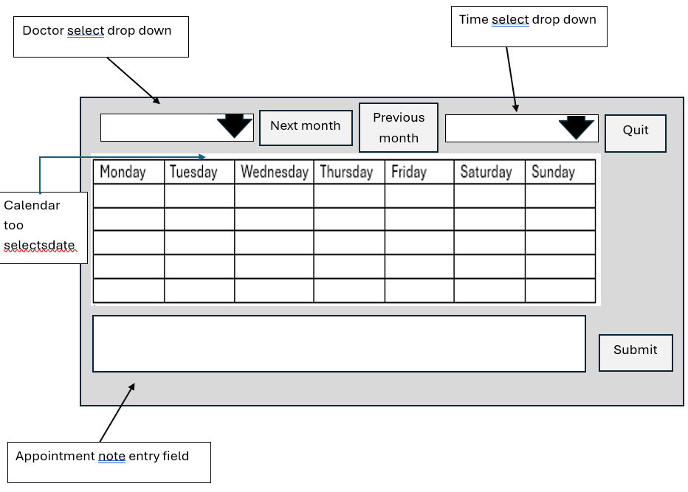
This form is the main menu form, simple form with buttons to take you from form to form.
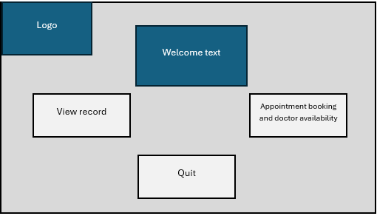
This form is the log in form. On the left is some welcome text and two the right is the login in field. You can input your login credentials and click submit to log in to the system. Under this is a forgot password button in the event you need to redo your password.
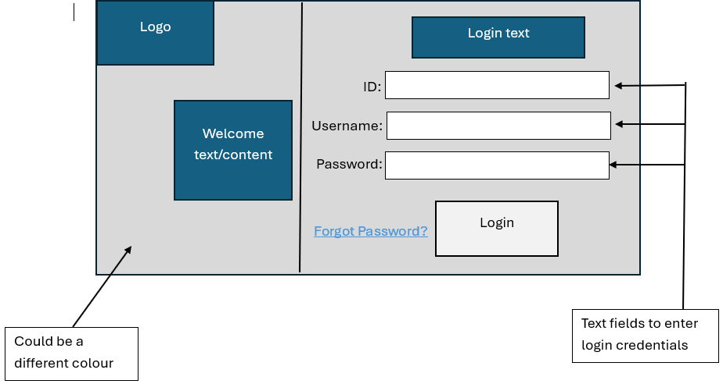

Fran:
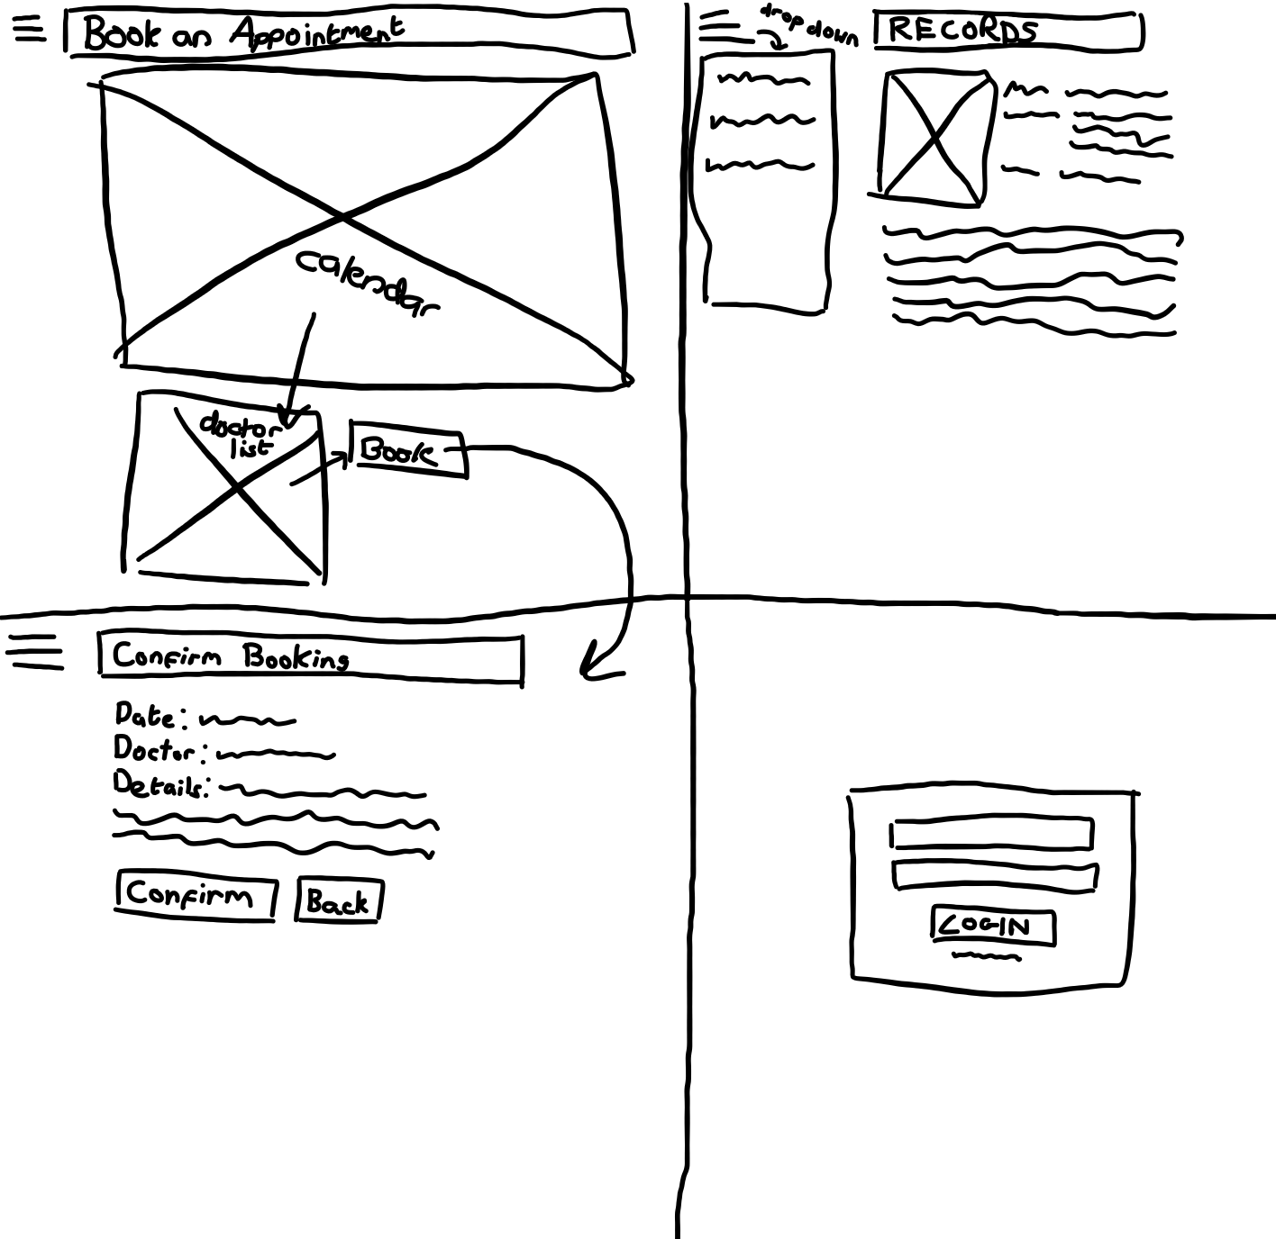
The bottom right wireframe is the login page, with space for a user input. Upon logging in, the user is then taken to the Records page (top right), which contains the user’s patient records, as well as a drop-down menu to access the bookings page. The booking page (top left) has a calendar from which the user can select the date of their appointment. Once they do, they can choose a doctor from the newly appeared list. Upon pressing the book button, they will confirm their booking (bottom left) and then be taken back to the booking page.

Final Wireframes
Rune:
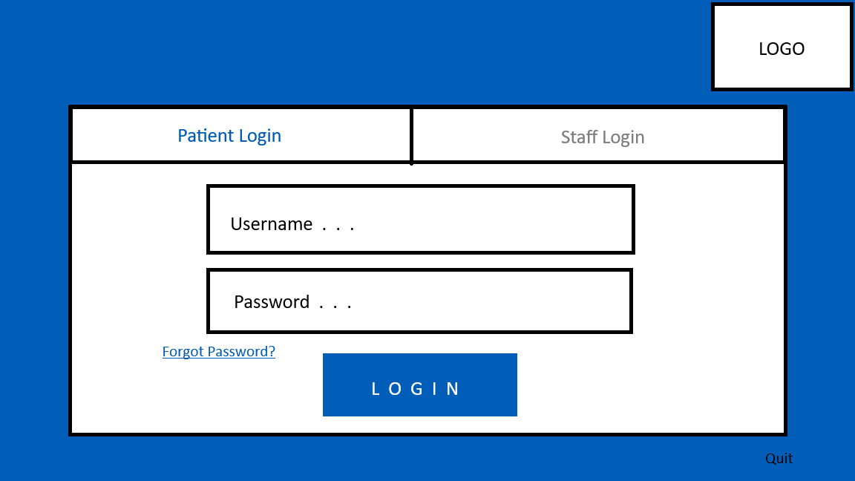

This is the patient login, it is mainly based on Nathan’s design with a few changes that make navigating the form easier, like a quit button. The login requires the patient to enter a username and password but if the patient forgets their password, they will click the button in the bottom left and be sent to a form to submit their details for a new password. All the wireframes reflect the colour scheme Nathan chose.
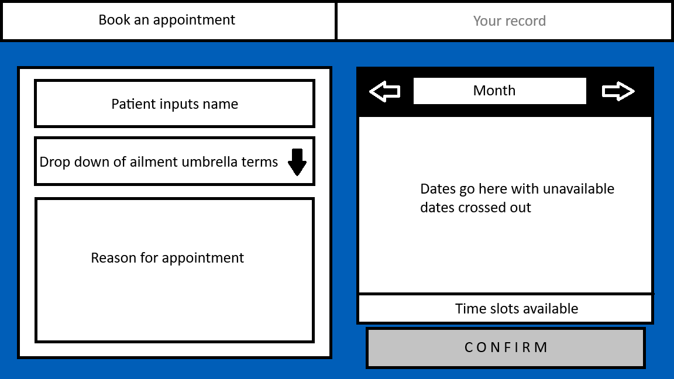

After the patient has logged in, they will be brought to the appointment booking system where they will fill out the form on the left and select a date/time to see the GP on the right. I have replaced the date selection dropdown menu with an illness type dropdown menu as this will streamline the data storing process. The calendar feature is bigger as this looked better in Fran’s wireframe mock up, it also allows for the date/time selection to be in the same section of the booking form. There is also a big “confirm” button, so patients know to confirm the booking.
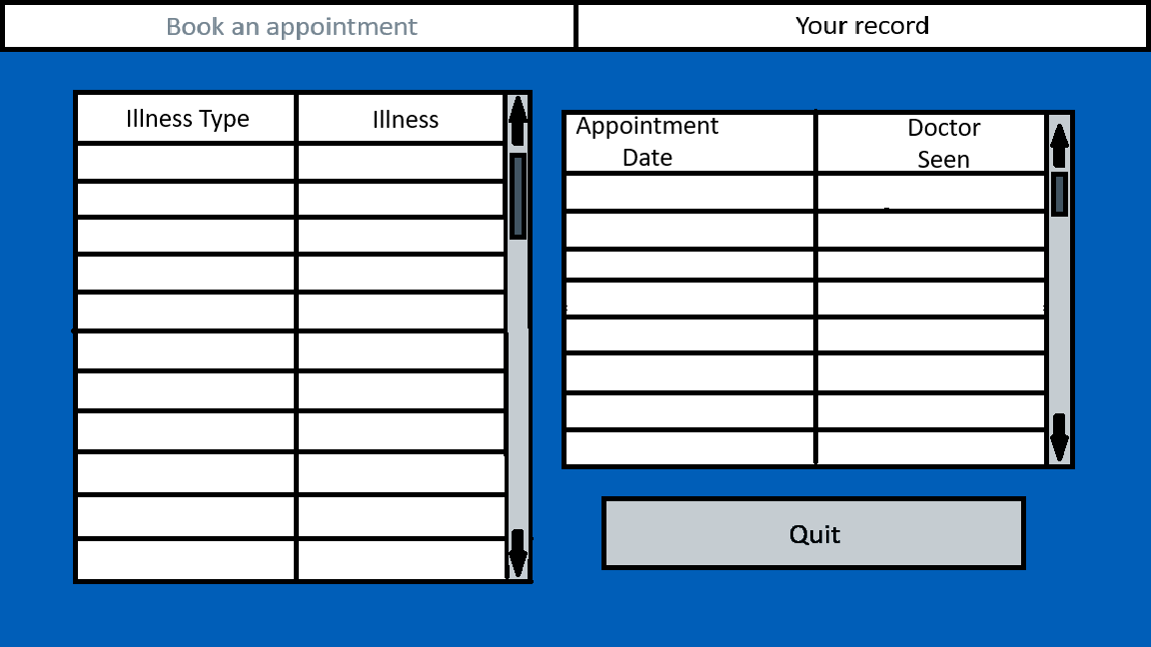
The patient can click through to “your record” which is where their medical/appointment data is kept, this is mainly based on Zach’s design. “Illness type” could be linked to the dropdown menu in the booking form as it uses the same categories, however this isn’t necessary. If we weren’t constrained by time, we would add the other elements of Zach’s patient records design like patient details.

Github link
https://github.com/ZW79Uni/Software-engineering-Assessment-1-Hospital-System

Personas

First Persona
Name: Jane Doe
Age: 84
Gender: Female
Description:
Jane has numerous medical issues so she would like a system to keep track of them all. She also wants this system to be as up to date as possible so that the doctors are aware of her various medical conditions.
She would also like a simplistic system so that it is not difficult to navigate as she struggles with using technology.
Second Persona
Name: John Doe
Age: 24
Gender: Male
Description:
An employed man with a very busy schedule. He wants to know when the doctors are soonest available.
He also wants his login credentials to be secure as he tends to reuse them for multiple accounts.
Finally, he wants his medical records to be secure.
Third Persona
Name: Bob James
Age: 44
Gender: Male
Description:
As a doctor, Bob wants to be able to update the system as quickly and easily as possible so that he doesn’t end up getting double booked. On top of this, he wants to be able to access patient's medical records, so that he can have a greater understanding of the patient.
He also wants the calendar to clearly state when he has been booked, so that he is aware if he has been booked.

Entity Relationship diagram (ERD)
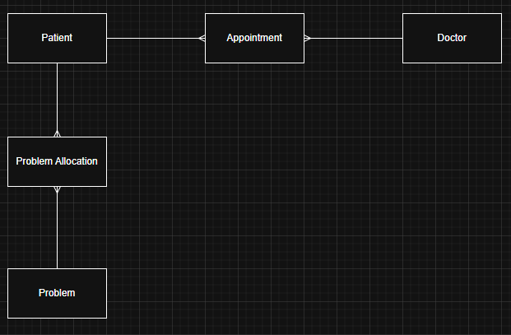

Logical Data model (LDM)
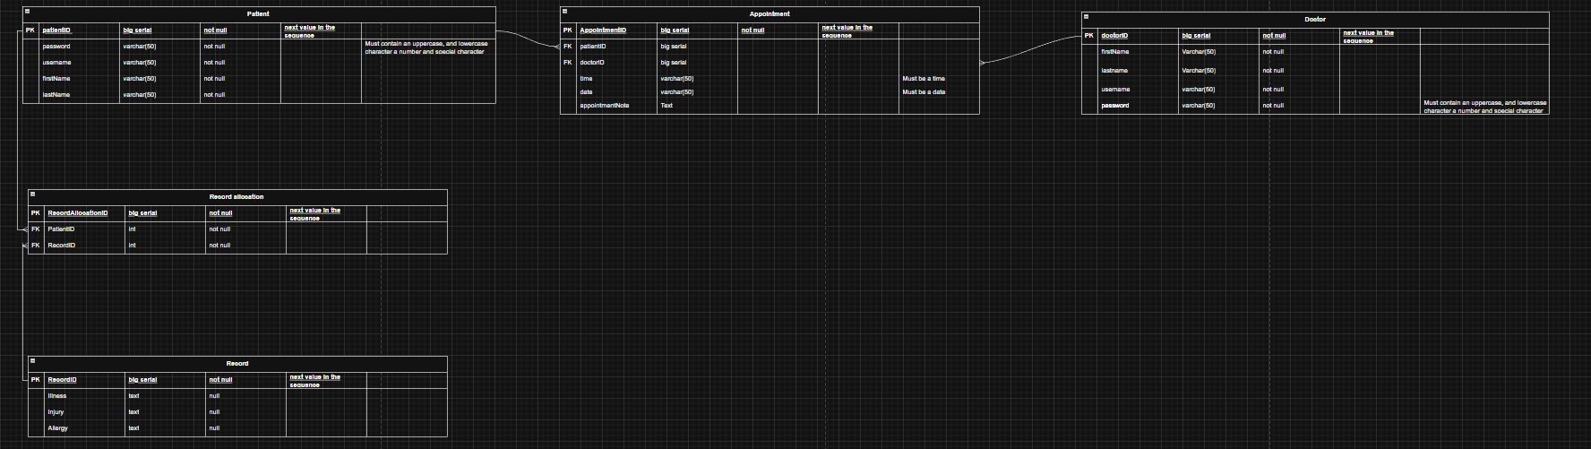

Hardware and software requirements

Hardware Requirements
As Windows Forms is not that hardware-intensive, the hardware requirements for this project would be relatively low, only needing 1GB of RAM and an x64 processor.

Software Requirements
In order to run this solution, you will need to have preferably the most version of windows, windows 11. Other than this making sure your system is up to date to make sure the system runs smoothly.

Product specification

Product Name
Hospital system

Problem to solve
The problem we aim to solve with this product is “How can patients book appointments, view their medical records and view doctor’s real-time availability without relying on hospital staff?”.

Target users
The target users for this product will be patients, doctors, and those who handle the hospital’s management. The main users of this product will be patients, most notably those who prefer “self-service” over in-person booking, those who cannot book in-person, or those who visit the hospital frequently and need quick, repeated bookings. Doctors in the hospital should also be able to use the product, selecting the dates they are available and viewing patient records and their current bookings.

Product Goal
With this product we are tasked to create a “patient centric hospital system that prioritises self-service”. The system is specifically outlined to specifically have “dynamic appointment booking interface, a secure personal portal for patients to view their own medical records, and a real-time calendar showing doctor availability for instant scheduling”. This means our solution that we develop has the objective of being a system for patients to view there medical records and book appointments with and view at the times of doctors. This system should aim to break down the inaccessibility of appointment booking while also making sure that this solution runs efficiently and quickly to avoid user frustration.

Scope
The final product must allow users to login and book appointments. The users will select a date and doctor to book an appointment with and, upon confirmation, will be added to the database.
The scope of the project will include:
- User/Doctor login
- Landing page containing user details
- Appointment booking
- Appointment confirmation (added to a database)

Out of Scope
With a clearly defined scope we also want to touch on what is out of scope for this project and why.
Starting with the database system (See tech stack section for more information) we decided to go for an SQLite database as opposed to more technical solutions such as MySQL or Azure cloud. The reasoning behind this is due to the limitations and resources available to us as a team with this being a prototype our client suggested we use SQLite to better capture the functionality while keeping the system simple.
Next is the operating systems, With the technology we are using to develop the solution (see the tech stack section) while it can have the capability to run on other operating systems such as MacOS and Linux, we do not have the means or resources to test this. As such the main focus of our support of this application will be for devices running the windows operating system, we could look into expanding direct compatibility with other operating systems in the future.
While these features and utilities would be nice to implement for the sake of getting the project done on time to a high standard it is wise to keep them out of scope. They could be considered for future updates and long-term support.

Key Features
The key features of this prototype for patients are being able to login and book appointments. Doctors will also be able to set their available dates and view appointments.

Tech Stack
To develop our solution, we will be using the following technologies. First, we will be using C# to develop the front end of the system. Specifically, we will be using the Windows form app template to help support us with development of this application, in addition we will also be using an SQLite database as one of the requirements for this solution is seamless and effective data storage and retrieval. We are using SQLite as opposed to other Relational database management systems like MySQL or PostgresSQL due to our constraints of not having access to their services for this project. As such we will use these instead.

Success Metrics
The product will be deemed “successful” if it can withstand and hold a moderate amount of user bookings, as well as allowing all these users to successfully login. The prototype must also allow doctors to select what days they are available, and for those days to be put on the bookings calendar.

Constraints
With this project we will be under constraints that could limit the success and feasibility of this project. First is Budgetary constraints. While we do not have any direct budget set we also are unlikely to need to spend anything, as our team is comprised of university students many resources we need are already provided to us. As such budgetary constraints are not to much of a concern. Next is time constraints, our deadline for this solution is the 30th of March 2026. This project will be divided into three different sprints. For the deadline to be met we must make sure we plan and keep track of deadlines to make sure we meet the deadline. Another constraint is safety and regulation. We must make sure our system meets various safety laws such as the general data protection act (GDPR) to protect our stakeholders who have their data stored within the system. Lastly is usability constraints in that we must make sure that our systems are accessible to all users and does not end up excluding users with disabilities or difficulties. These constraints must be followed so that the system meets the ethical and legal requirements a system like this would require.

Evaluation of solution

